Packages:
solarCalculations.klaus: Offers two algorithms for calculation the position of the sun (as seen from earth)
solarCalculations: Offers methods for calculating Air Mass and Intensity (W/m²)

------------------------------------------------------------------------------------------------------------------------------------
Azimuth: Direction of the sun measured from North axis. Altitude CAN be measured from Azimuth.
ZenithAngle: The ZenithAngle, as used in the “solarCalculations.klaus”-Package, is measured from the Zenith. Therefore 0° would result in an Air Mass of 1 (optimal).
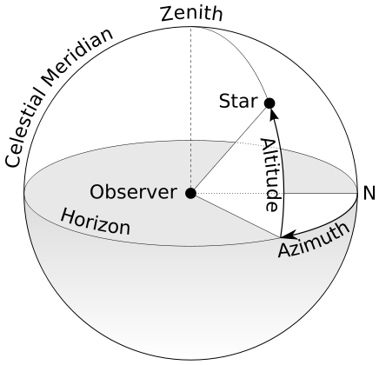

In August, the International Astronomical Union -- which you may remember as the body that demoted poor Pluto to dwarf planet status in 2006 -- voted to fix the astronomical unit, which designates the distance between the sun and Earth, at 149,597,870.700 meters (92,955,807.273 miles). The new fixed distance replaces a complicated equation that served as the previous definition of an astronomical unit..

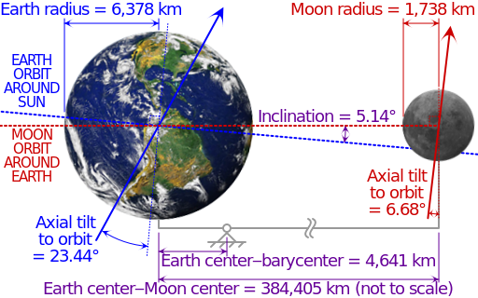

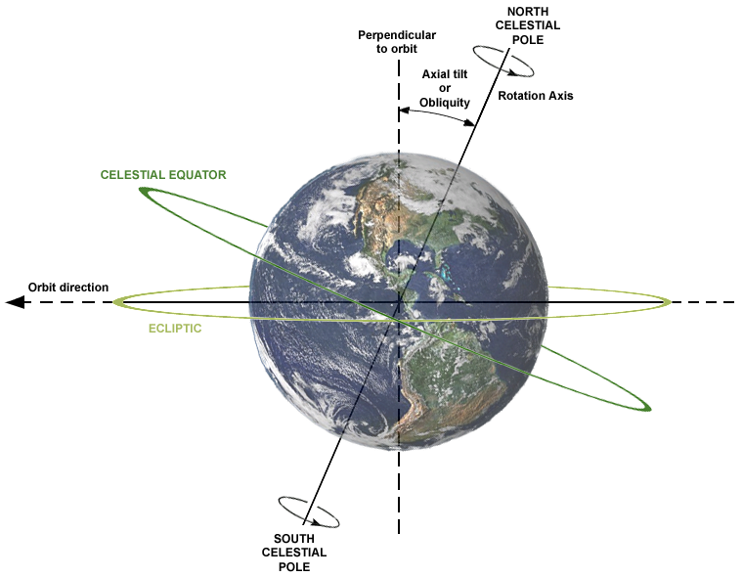
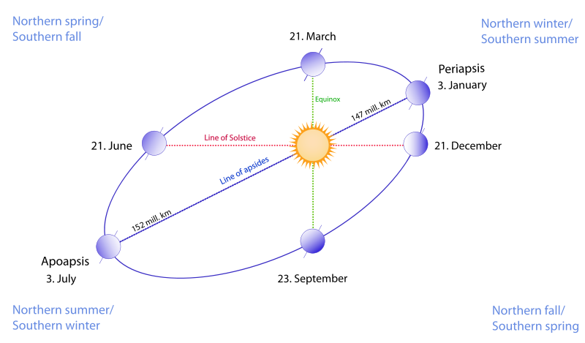

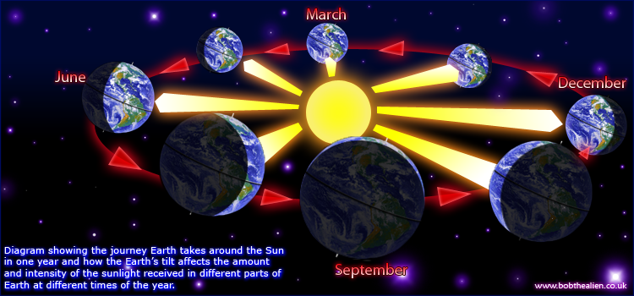

Speed of light: 299 792 458 m/s
365,256363004 days
~149 597 870,700 km

Earth:
R = 6 371,0 km (6 378,1 – 6 356,8)
510 072 000 km²
1,08321 * 10^12 km³
23,44°

Sun:
R =696 000 km +- 10/2km
1,4 * 10^18 m³ = 1,3 * 10^6 * EARTH

